Credit: Khuram Malik, SEBT

Yoursite.com

flstatewideinsurance.com
Search Engine Optimization Audit

SEO EXECUTIVE SUMMARY 5

Top Content Action Items

Top Indexing Action Items

Top Linking/Social Action Items

SEO SCORECARD 6

CONTENT OVERVIEW 7

Content Analysis

Content Score

KEYWORD FOCUS 8

Analysis

Recommendations

Guidelines

URL STRUCTURE 9

Analysis

Recommendations

Guidelines

TITLE TAGS 10

Analysis

Recommendations

Guidelines

META DESCRIPTION TAGS 11

Analysis

Recommendations

Guidelines

META KEYWORDS 12

Analysis & Recommendations

Guidelines

HEADING TAGS 13

Analysis

Recommendations

Guidelines

CONTENT 14

Analysis

Recommendations

Guidelines

INTERNAL LINKING & ANCHOR TEXT 16

Analysis

Recommendations

Guidelines

IMAGE NAMES & ALT TAGS 18

Analysis

Recommendations

Guidelines

NOFOLLOW ANCHOR TAGS 19

Analysis

Recommendations

Guidelines

INDEXING OVERVIEW 20

Top Indexing Action Items

Indexing Analysis

Indexing Score

INDEXING OPTIMIZATION ANALYSIS 21

PAGE EXCLUSIONS 22

Analysis

Recommendations

Guidelines

PAGE INCLUSIONS 23

Analysis

Recommendations

Guidelines

URL REDIRECTS 24

Analysis

Recommendations

Guidelines

DUPLICATE CONTENT 25

Analysis

Recommendations

Guidelines

BROKEN LINKS 26

Analysis

Recommendations

Guidelines

CODE VALIDATION 28

Analysis

Recommendations

Guidelines

PAGE LOAD SPEED 29

Analysis

Recommendations

Guidelines

LINKING ANALYSIS OVERVIEW 31

Linking Analysis

Linking Score

INBOUND FOLLOWED LINKS 32

Analysis

Recommendations

Guidelines

LINKING ROOT DOMAINS 33

Analysis

Recommendations

Guidelines

AUTHORITY & TRUST 34

Analysis

Recommendations

Guidelines

SOCIAL MEDIA MENTIONS & VISIBILITY 35

Analysis

Recommendations

Guidelines

COMPETITIVE LINK COMPARISON 36

Analysis

CONCLUSION 37

List of Supporting Documents

SEO EXECUTIVE SUMMARY

yoursite.com has scored a 61% for overall SEO-ability. This is good, but still leaves significant room for improvement. This prioritized list shows the key elements to optimize, from highest to lowest priority, for the three main areas of SEO;Content, Indexing and Linking/Social.

Top Content Action Items

- Keyword Focus

The site as a whole has a keyword focus, but its using less competitive keywords that won’t drive more traffic, it can be further improved.
- Title Tags
  - 6 Title tags are too long, 2 are same as H1, 8 are duplicates, 3 are too short, and 0 is missing.
- Meta Description Tags

0 pages have duplicate Meta descriptions, 3 are too long, 1 is too short and 36 are missing
- Image Names and ALT Tags
8 Images are missing ALT tags and not all images had descriptive, keyword focused file names.

Top Indexing Action Items

- Page Exclusions
- No pages are excluded from indexation.
- Page Load Speed
- Page load speed is 4.04 sec, you can improve page load speed by reducing page file size and number of requests.
- Code Validation
- Code validation is good.

Top Linking/Social Action Items

- Linking Root Domains

Increase both the quantity and quality of linking root domains.
- Inbound Followed Links

Work to build out more keyword rich anchor text links for non-branded keywords while also working to increase the overall quantity and quality of inbound links.


Simply start with #1 in each category and work your way down the list. By implementing the changes that we have recommended, the website will be well on its way to achieving more excellent rankings for its chosen keyword phrases.
SEO SCORECARD

SEO ELEMENT | - SCORE
Keyword Focus | 5
URL Structure | 10
Title Tags | 7
Meta Description Tags | 5
Meta Keyword Tags | 0
Heading Tags | 6
Content | 9
Internal Linking and Anchor Text | 7
Image Names and ALTs | 7
NoFollow Anchor Tags | 8
On-site SEO Score (26% of Algorithm) | 61%
- Page Exclusions | 10
- Page Inclusions | 10
- URL Redirects | 10
- Duplicate Content | 8
- Broken Links | 5
- Code Validation | 6
- Page Load Speed | 7
- Indexing Score (12% of Algorithm) | 83%
Inbound Followed Links | 7
Linking Root Domains | 7
Authority and Trust | 6
Social Media Mentions and Visibility | 8
Competitive Link Comparison | -
- Linking/Social Score (62% of Algorithm) | 86%
- OVERALL SEO SCORE | 61%

A score of 10 is perfect execution and a score of 1 means that element is missing entirely. These areas are addressed in the following report. In each overview section the issues are color coded as follows:
Red = Major Issues (1-3) | Yellow = Some Issues (4-7) | Green = Minor Issues If Any (8-10)

CONTENT OVERVIEW

Top Content Action Items

- Keyword Focus
- Title Tags
- Meta Descriptions
- Image Names and ALT Tags

Content Analysis

This analysis addresses all of the on-site SEO content related issues found on the website. Implementing the recommended changes should provide valuable SEO benefits. There are 10 main on-site SEO topics covered, as follows:
- Keyword Focus
- URL Structure
- Title Tags
- Meta Descriptions
- Meta Keywords
- Heading Tags
- Content
- Internal Linking and Anchor Text
- Image Names and ALT Tags
- NoFollow Anchor Tags

Red = Major Issues (1-3) | Yellow = Some Issues (4-7) | Green = Minor Issues If Any (8-10)


For each main on-site SEO topic, there are 3 sub sections: Analysis, Recommendations and Guidelines.
Score
82%

- SCORE
- 61%
- The Analysis section details the findings from our analysis.
- The Recommendations section identifies our proposed action items.
- The Guidelines section gives specific instructions for implementing the required changes.

Content Score

The website has an On-Site SEO Score of 50%. This indicates above average on-site SEO-ability. Correct implementation of the proceeding guidelines will help to improve existing rankings, and to rank for more competitive keyword phrases in the future.

URL STRUCTURE

Analysis

We found the URL structure to be good. A few, pages had URLs that had underscores (-) in them. For example:
URL | URL LENGTH

There are no URLs that exceeded 100 characters or used uppercase letters and no pages with duplicate URLs. It makes the URL structure overall great and perfect.

Recommendations

Ideally, no URL should be longer than 100 characters in length. If possible, create shorter URLs for any pages that exceed this limit (if you change a URL, 301 redirects will be necessary). The attached site crawl report will help you to identify the URLs in need of optimization. That said, keep in mind that this is far from a critical issued, and could safely be ignored.

Guidelines

A site’s URL structure is extremely important to both users and search engines. Poor URL structure can hurt rankings, prevent pages from being indexed and lower your click-through-rate (CTR).


It is extremely important that URLs be readable, user friendly, and that they contain the keyword of the page. Always separate keywords with dashes, not underscores. If relevant, a geo-qualifier (such as Vancouver, BC) should also be included. URL file names should always be written in lowercase letters.

- SCORE
- 10/10

URLs should also be relatively short, with 100 characters in length being the current SEO best practice. While longer URLs aren't necessarily bad, the shorter the URL the less likely that URL is to truncate in search results and the more likely it is to have a positive impact on SERP click-through-rates.

If query parameters are necessary for analytics or paid advertising reasons, make sure to use Google and Bing Webmaster Tools to tell search spiders to ignore those parameters from an indexing perspective. It won’t impact your tracking, but will prevent any indexing issues related to parameters from occurring. Make sure that parameter pages are not linked to internally.

TITLE TAGS

Analysis

URL & Titles

We found 6 pages where the Title tags exceeded Google’s truncation limit, 3 that are too short, 8 duplicates, and 0 pages that are missing a Title tag.

While existing Title tags were fairly well written overall. The home page Title tag epitomizes this; while branded, it lacked some keyword focus, and is one of the most important places on a site for keywords to be used.

Recommendations

We recommend that optimized Title tags be re-written for each page that has an overly long, short or otherwise un-optimized Title tag. We particularly recommend writing a new home page Title tag.

Guidelines

After the URL, the second most important place on a page to have the keyword is the Title tag. The Title tag is the first description of the page that search engine users will read, and it is extremely important to both users and search engines that it contain the keyword they are searching for. This will not only help to improve rankings, but can significantly improve your click-through-rate as well.

A proper Title tag will:
- Be 15-60 characters in length (50-60 is ideal).*
- Be unique to that page (don’t use the same title tag on multiple pages).

- Use the keyword of that page twice if space permits (once at the start, followed by separator such as a colon, hyphen, or pipe, and then once again in a call to action). If the character limit prevents the use of the keyword twice, use it once in a good call to action, with the keyword as close to the beginning of the Title tag as possible.

Score
7/10

#

- SCORE
- 6/10
- If relevant, include a geo-qualifier (such as Washington or Seattle, WA).

* While you may hear some SEOs say to limit Titles to 70 characters, it's a misconception. Google is actually using a pixel width limit, not a character limit. Title tags appear in 12pt Arial font by default, with searched for keywords bolded, and Google has a pixel width limit of 520 pixels.

Using 60 characters as your Title character limit will avoid truncation in the vast majority of cases.

You can see if a Title will truncate by doing the following: simply use Excel, set column width to 520px, set columns to wrap text, and font to Arial 12pt. Type in your Title, and bold the main keyword. If the line breaks, your Title tag will truncate. (You can alsouse this tool to check.)

One example of a proper title tag structure might be:
- <title> | </title>

META DESCRIPTION TAGS

Analysis

36 pages were missing Meta description tags, 0 pages have duplicate Meta descriptions, 3 Meta descriptions are too long and 1 pages have too short, 1 page on the site has 2 Meta description tags.

Recommendations

We recommend that unique, keyword and user targeted Meta description tags be re-written for each page that has two tags, or that is currently missing a description (every page on the site). Every page on a site should have a unique, keyword optimized Meta description tag.

Guidelines


While Meta description tags are a factor in the ranking algorithm, they are also used as the description searchers will see in the search engine results. Having the keyword used properly in the Meta description tags can increase the likelihood that users will click on the link to the page if the keyword usage matches their search query.

Score
6/10

- SCORE
- 5/10

Meta descriptions should adhere to the following guidelines:
- Be unique and relevant to that page.
- Be written as descriptive ad text, with a call to action.
- No more than 160 characters in length including spaces and punctuation (140-150 is ideal), but no less than 51 characters (Google considers 50 characters or less to be too short).
- Contain 1-2 complete sentences with correct punctuation, and no more than 5 commas.
- Use the keyword once per sentence, as close to the start of each sentence as possible.
- Include a geo-qualifier, such as “Seattle, WA”, if relevant.

A proper Meta description tag example might be:
- <meta name=”description” content=” The real estate signage options make it easy help advertise at your location. Hundreds of items are in stock at Slimline Warehouse for your business today!!”/>

HEADING TAGS

Analysis

0 pages are missing H1 tags, 59 pages have duplicate H1 tags and 6 H1 tags are too long. 63 pages have multiple description tags. 66 pages on the site make use of H2 tags and all 66 are duplicate.

Recommendations

You should consider adding H1 tags to the pages that are missing them, and you should make sure that heading tags in general are unique & use keywords more effectively where relevant.

Guidelines

Search engines weight text for SEO value based on text size and position on the page. Heading tags are supposed to be larger than the other text on the page, and should appear prominently on the page, thus the added benefit of having the keyword in the heading tags.

Every page should have an H1 tag, as search engines look to the H1 to help determine the topic of a page. It should be the first thing in the body text of the page, and should appear prominently.


H1 tags should never contain images or logos, only text. The keyword of a page needs to be used in the H1 tag, and in at least half of the total heading tags on a page, if more than one heading tag is present.

Score
10/10

- SCORE
- 7/10

From a usability perspective, paragraphs should never be longer than 5 lines of text, and it is wise to break up a page every 2-3 paragraphs with a sub-heading in the form of an H tag (H2 or H3) or an image. Testing has shown that when users are faced with a large block of unbroken text, most either skim over the text or skip it altogether, so content needs to be divided into usable chunks.

It is important that the keyword of a page be used in the H1 tag, as close to the beginning of the H1 as possible. Ideally, there should be at least one additional H tag on each page that contains the keyword, for added SEO value. Heading tags are a nested element, and should be used in the correct order.

No H tag should be used of the preceding numerical tag has not been used (don't use an H2 if there is no H1, don't use an H5 if there is no H4, etc.).

CONTENT

Analysis

Currently on the website, the content situation is as follows:

- Keyword Usage in Content
Keyword and variations used? One or two main keywords per page?
- Content Amount/Quality
# of words, spelling, grammar, unique, useful
- For some of the pages we looked at there appeared to be a significant amount of unique, topically focused and user useful content. The content tends to be very well written.

- Content Growth

Score
8/10

- SCORE
- 8/10
- New content added regularly? Existing content updated from time to time?
- The site is static, and new content isn’t added very regularly. Some content might be periodically updated, but the main focus isn’t on adding fresh content frequently.
- Media to Text
If Flash or images contain text, is it also available in readable html text?
- While there are some images that contain text, ALT tags are generally used correctly.

Recommendations

You should optimize your content and make the site thicker. You should consider building out more top-level pages too.

Guidelines

One of the most important on-site SEO elements is text content, and search engines want to see a significant amount of unique text on each page. Under ideal circumstances we would recommend having 400-600 words of unique text per page, though we believe the safe minimum is 300 words.

For usability reasons, no page should ever be longer than 800 words (with the exception of blog posts). This content needs to contain the relevant keywords for the page. Having unique, keyword rich text on a page can help to improve search engine rankings significantly.

Duplicate content is viewed as a big negative. It can not only hurt rankings, but can prevent a page from ranking. Search engines want to see unique content on a site, and can penalize a site for using duplicate content. Using flash or images in place of text is considered a big negative. While search engines like a variety of media, itmust not take the place of text. Consider using Flash replacement text, like SIFR.
INTERNAL LINKING & ANCHOR TEXT

Analysis



We didn’t find a significant amount of internal linking throughout the site, which isn’t a perfect situation!.

However, internal navigation is using a mix of relative URLs (/) and absolute URLs (http://flstatewideinsurance.com/). This can sometimes cause indexing issues, and is not advised. Only absolute URLs should be used for internal linking. (The Home link is the only relative that we found.)

Some pages contain more than the recommended limit of 100 links per page, but this is due largely to the comment system. While not ideal, this isn't a critical issue.


However, the site contain a number of site-wide links pointing to an external domains (http://www.corelogic.com/ , https://www.nachi.org/pb.htm , http://www.sun-sentinel.com/topic/politics/government/mary-l.-landrieu-PEPLT003755.topic), and this isn’t ideal. Not only do site-wide links tend to be discounted, but by doing this you are essentially leaking authority and PageRank from every page on the site to these external domains.

- SCORE
- 7/10

Recommendations

We recommend that absolute URLs be used internally, not relative URLs. We also recommend that the total number of links on each page be reduced as needed to keep the total fewer than 100 links per page to stay in-line with SEO best practices. This might require re-coding the comment system to prevent commenter names from being links.

Also, minimize instances of external linking from within the site. If site-wide links must be used, we recommend implementing NoFollow tags on all such links.

Guidelines

It is very important to cross link within the pages of one’s site using keyword rich anchor text, though you should do so sparingly. Pages of similar topic should cross link to each other using they keywords of those pages in the anchor text. We recommend 2-3 keyword rich internal links on any given page.

In addition to linking from within the text of a page, keyword relevant anchor text should be used in the main navigation elements. Where space prevents the use of a relevant keyword for the page being linked to in the navigation, it is important to include the title element in the anchor tag, as follows:

Score
10/10

<ahref=”http://www.QuickSprout.com/” title=”Neil Patel's Digital Marketing Blog”>Home</a>

The same goes for links outside of the site. Approximately 15-30% of all inbound links from blogs, forums, press releases, or any other external link building should include the keyword of the page being linked to in the anchor text of the link (or a close variation).
IMAGE NAMES & ALT TAGS

Analysis

While many of the main images throughout the site had ALT tags, relatively few of the images found on the site had descriptive, keyword rich image names.

MISSING ALT TEXT

http://yoursite.com/wp-content/uploads/2015/04/FLsliders-21-627x358.png

http://yoursite.com/wp-content/uploads/2015/04/FLsliders-41-627x358.png

http://yoursite.com/wp-content/uploads/2015/04/FLsliders-61-627x358.png

Recommendations

We recommend that ALT tags be written for each image (including design elements like borders, buttons, etc.) that currently doesn’t have ALT tags. Keywords should be used in ALT tags.

Guidelines


For the benefit of search engines, code compliance, and visually impaired users, every image MUST have an ALT tag. The ALT tag should contain a keyword relevant to the page/en-us (but only if the keyword is relevant to the image as well).

- SCORE
- 7/10

Image file names should be descriptive words, not numbers or query strings. They should accurately describe the image, and if relevant should also use the keyword. If an image is used as a link, then the ALT tag functions in place of anchor text. A linked image should follow this structure:
<ahref=”http://www.targeturl.com/”><img src=”http://www.domain.com/images/keyword-rich-image-name.jpg” alt=”use a keyword if relevant” /></a>
By ensuring that all images are properly named and tagged, you will not only increase the SEO value of those images, but you will increase the likelihood of receiving referral traffic from image search results.
Also, for code compliance reasons, all images should also specify a height and width in the image tag.
NOFOLLOW ANCHOR TAGS

Analysis

NoFollow tags are not being used in numerous places throughout the site, and the usage appears not to be correct. While there are additional places we feel the NoFollow tag should be used.

Recommendations

You should consider adding NoFollow tags to some of the site-wide links that point to other websites present on the site.

Guidelines

Google measures how different pages link together, and assigns a weight to those links based on traffic, relevancy, age, size, content, and hundreds of other components.


When pages that Google deems relevant link to other pages, some of that “Link Juice” flows through that link to the site being linked to. A “followed” link is essentially endorsing the page being linked to.

- SCORE
- 8/10

Enter the rel=”nofollow” tag. Google introduced this tag to help preserve the relevancy of PageRank, which was being hurt by blog and forum comment spammers. When the tag rel=”nofollow” is used in an anchor tag (link), Google will usually pass 50-100% less "link juice" to the page being linked to. Using this tag is like saying "this page is nice, but we don’t really endorse it."

NoFollow tags should be used on blog comments, site-wide external links, and on any internal links pointing to low quality or otherwise user-worthless pages.

INDEXING OVERVIEW

Top Indexing Action Items

- Page Exclusions

- Page Load Speed
- Code Validation

Indexing Analysis

This analysis addresses all of the SEO Indexing related issues found on the website. Implementing the recommended changes should provide valuable SEO benefits. There are 7 main SEO indexing topics covered, as follows:
- Page Exclusions
- Page Inclusions
- URL Redirects
- Duplicate Content
- Broken Links
- Code Validation
- Page Load Speed

Red = Major Issues (1-3) | Yellow = Some Issues (4-7) | Green = Minor Issues If Any (8-10)


For each main SEO indexing topic, there are 3 sub sections: Analysis, Recommendations and Guidelines.

- SCORE
- 83%
- The Analysis section details the findings from our analysis.
- The Recommendations section identifies our proposed action items.
- The Guidelines section gives specific instructions for implementing the required changes

Indexing Score

The website has an Indexing SEO Score of 50%. This indicates average index-ability. Correct implementation of the proceeding guidelines will help to improve its existing rankings, and to rank for more competitive keyword phrases in the future.
INDEXING OPTIMIZATION ANALYSIS

Often, we find large variances in the pages that each search engine decides to keep in their index for their users. This is usually a symptom of one large or several small indexing problems. Websites with smaller variances of pages indexed between the search engines have very few if any indexing problems.


For the site Google has 61 URLs indexed, while Bing has 0. However, our crawl found 66 static, index-able, non-parameterized URLs reachable by a link-to-link crawl.

Score
5/10

- SCORE
- 83%

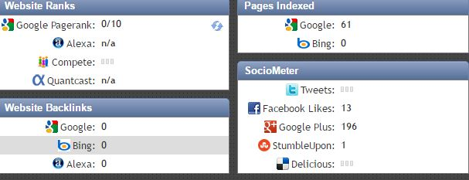

This level of variance means that there are indexing issues present that are causing the search engines to maintain an incorrect index. The proceeding recommendations will reduce the confusion of pages available to the search engines and help in the maintenance of the website. Every page indexed enables the domain to rank for search terms contained on those pages, which means an additional point of entry. This is why it is important to keep track of how many pages there are and how many are indexed.
PAGE EXCLUSIONS

Analysis

A robots.txt file was found, and was very well optimized. Page level Meta robots tags such as the NoODP and NoYDir tags were present and used correctly. In addition, typical Wordpress /page/ issues were handled with NoIndex tags.

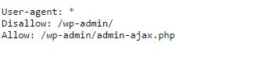

Recommendations

Everything looks good and nothing is required for now.


Score
10/10

- SCORE
- 10/10

Guidelines

Effectively covering the function of the robots.txt file here isn’t possible. To learn more about robots.txt best practices, simply visit this page: http://www.robotstxt.org/robotstxt.html

If you ever have a page that you don’t want Google to index, but that has links you do want Google to crawl, at that time you would need to implement a page level tag. Page level Meta robots NoIndex tags would be particularly useful on any page of your site that you would not want a searcher to enter on, such as a thank you pages, privacy policy pages or T&C pages.
PAGE INCLUSIONS

Analysis

Page inclusions consist primarily of creating an XML sitemap and submitting it through your Google and Bing Webmaster Tools accounts. We found that the current sitemap is an Html URL page on the site that is hurting it a lot.

Recommendations


Create a proper xml sitemap, upload & submit it to all Gwt.

Score
10/10

Score
10/10

- SCORE
- 10/10

Guidelines

An XML sitemap should be created for every website, and should be updated and re-submitted whenever changes are made to the site. Additional information about XML sitemaps can be found here:
http://www.google.com/support/webmasters/bin/answer.py?answer=156184

URL REDIRECTS

Analysis

The standard non-WWW to WWW redirects are in place. 301 redirects appeared to be used correctly. However 3 redirects with 302 response were also found.

Recommendations

No changes are needed at this time with 301 redirects but all the 302 redirects should be removed and replaced with 301.

Guidelines


Unless a redirect is truly temporary (such as for a time sensitive promotion), 302 redirects should never be used. 302 redirects don’t pass any link value, and are essentially a dead end for SEO. In almost every scenario where a redirect is needed, a 301 redirect should be used.

- SCORE
- 10/10

Any page that changes URLs or is deleted needs a 301 permanent redirect to tell search engines and users that the page has moved/is gone. There should never be more than one URL path to a page.
DUPLICATE CONTENT

Analysis

We found some instances of duplicate content on your site. We did not find any coding issues present that could create potential duplicate content problems that were not already addressed correctly.

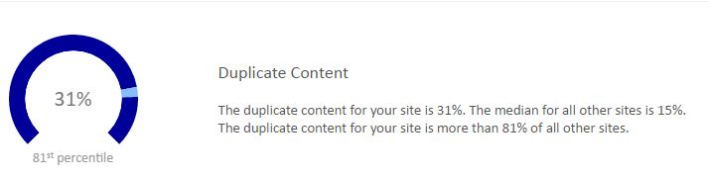

Recommendations

Try to minimize your duplicate content.

Guidelines

Search engines really don't like duplicate content, as it leads to a poor user experience and other content quality issues. If you have duplicate content, you need to do everything you can to eliminate it.

There are 4 main options for addressing duplicate content:
- Fix the URL structure of the site to eliminate accidental duplicate content coming from URL issues, per the recommendations in the URL Redirects section and this section.
- Re-write all duplicate text content to make it unique.
- 301 redirect the duplicate content to one canonical page/site, if it is in your control.
- Implement the rel="canonical" tag to identify the original source/root page to search engines.

You specify thecanonical version of the URLusing a tag in the head section of the page as follows:
<linkrel="canonical" href="http://flstatewideinsurance.com"/>



- SCORE
- 8/10
Google makes a pretty serious effort to find duplicate content and keep it out of its index, so this is not something to take lightly.

BROKEN LINKS

Analysis

Google Webmaster Tools for the site identified 0, error pages with 404 response code and 0 no response pages, that will need to be 301 (permanently) redirected to the most appropriate page.

404 PAGES

No 404 pages found

Recommendations

Nothing needed for now but if 404 pages are found then, Implement a 301 redirect for any 404 page, pointing to the most appropriate live URL. In the future, whenever any changes are made to the URL of a page that has previously been live, you will need to implement a 301 redirect pointing the old URL to the new URL. You will also need to change all internal links on the site that point to the old URL to point to the correct new URL.

Also, regularly monitor Google and Bing Webmaster Tools for crawl errors (broken pages and other site errors) and assign someone to create 301 redirects for any broken pages that are found.

Guidelines


Because Google and other search engines crawl the web link-to-link, broken links can cause SEO problems for a website. When Google is crawling a site and hits a broken link, the crawler immediately leaves the site. If Google encounters too many broken links on a site it may deem that site a poor user experience, which can cause a reduced crawl rate/depth, and both indexing and ranking problems.

- SCORE
- 9/10

Unfortunately, broken links can also happen due to someone outside of your site linking in incorrectly. While these types of broken links can’t be avoided, they can be easily fixed with a 301 redirect.

To avoid both user and search engine problems, you should routinely check Google and Bing Webmaster Tools for crawl errors, and run a tool like XENU Link Sleuth or Screaming Frogon your site to make sure there are no crawlable broken links.

If broken links are found, you need to implement a 301 redirect per the guidelines in the URL Redirect section. You can also use your Google Webmaster Tools account to check for broken links that Google has found on your site.

CODE VALIDATION

- SCORE
- 5/10

Analysis

We ran the home page through the W3C Validation Tool, and this was what we saw:
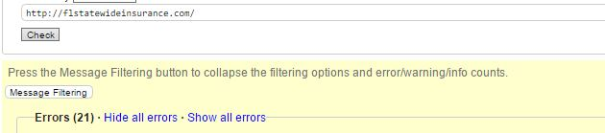

Errors are fairly common, 21 errors and 9 warnings mean your site couldn’t potentially have trouble on browsers, and can’t potentially pose a problem to search engine spiders.

Recommendations

While it isn’t strictly necessary, you would ideally want to make whatever code changes you need to make to ensure sure all pages on the site validate at 100% via the following validator to err on the side of caution.

In addition to validation via W3.org, you will want to test the site on all major browser types to make sure that there are no cross-browser compatibility issues (you can do this with Adobe’s Browser Lab tool).


Guidelines

- SCORE
- 6/10

The W3C markup validator service can be found at this location http://validator.w3.org/.

Because there are so many programming languages and so many ways to accomplish any one thing using each language search engines rely on certain rules in which they read the content of the website.

Having code that adheres to these rules removes and helps to minimize errors when parsing or separating the code from the content of any one page.

Search engines such as Google have openly stated that W3C standards are what they suggest when making the code easy to understand for them. We typically only test the home page of the website, because many issues can be easily fixed a crossed the entire website using just its page templates.


PAGE LOAD SPEED
- SCORE
- 7/10

Analysis

When we scanned your site using Pingdom Tools, we found the following:

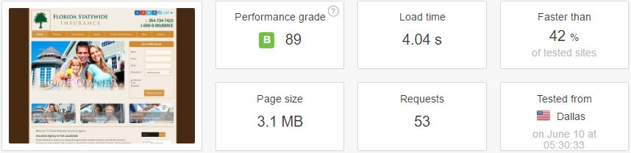

While a page load speed of 4.04 seconds is considered slow, we feel that the load speed shown on this scan was incorrect. Based on the number of requests and the page size, we believe the load speed is likely in the 5 seconds range. Webmaster Tools or Google Analytics can provide a more accurate page load speed. If the page load speed really is in the 5 seconds range as we believe it is, that is below average, and is slow enough that it is almost certainly impacting your conversions, especially on mobile devices.

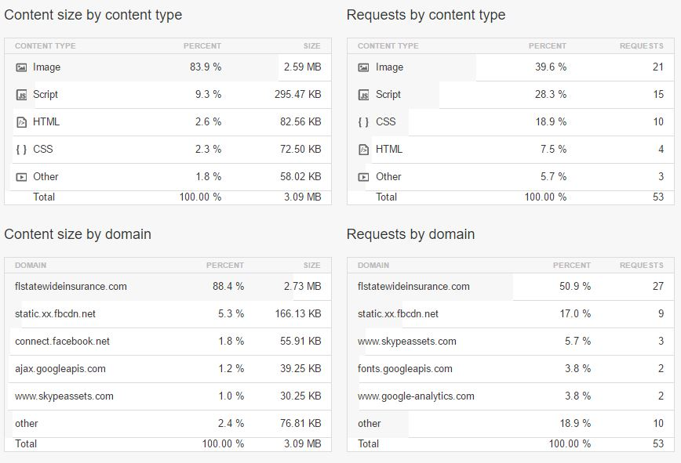

53 requests is a significant number, and the number of items loading is a key factor in load speed. We recommend that no page call in more than 40 times, preferably fewer if possible. In addition, a page size of 3.1 mb is significant. We recommend that page size be kept to 500kb or less to avoid load speed issues. We saw no use of compression or minification to minimize file sizes.

Recommendations

There are a few things you can do to increase that page load speed to reach Google’s recommended page load speed of 1.4 seconds or less. We would recommend leveraging browser caching, CSS Sprites for images where possible, and reducing the image file sizes as much as possible for images that can’t be spirited (different file types, removing unnecessary color channels, etc.).

We would also recommend reducing the total number of CSS and JavaScript files by combining them into fewer files, and minimizing the file sizes by using compression and minification where feasible.

You might also see benefits by using a content delivery network (CDN)for your images.

W3 Total Cache is an excellent Wordpress plug-in that can help with page load speed issues, and a simple CDN can be set-up via Amazon AWS for very little money. You can learn how to do this here.

Guidelines

On April 9th, 2010,page load speed officially became a part of the Google search ranking algorithm. For usability reasons, best practices dictate that a web page should load within 1-2 seconds on a typical DSL connection. However, according to Google Webmaster Tools data a load time of 1.4 seconds is the threshold between a fast page and a slow page. That means, ideally, that every page on your website should load in 1.4 seconds or less, to receive the maximum SEO benefit for fast loading pages.

Google gathers page load time data through actual user experience data collected with the Google search toolbar, and may also be combining that with data collected as Google crawls a website. As such, page load speed in terms of the ranking algorithm is being measured using the total load time for a page, exactly as a user would experience it.

LINKING ANALYSIS OVERVIEW

- Top Linking Action Items

- Linking Root Domains
- Inbound Followed Links

Linking Analysis

This analysis addresses the key linking related issues found. Implementing the recommended changes should provide valuable SEO benefits.

There are 5 main linking topics covered, as follows:
- Inbound Followed Links
- Linking Root Domains
- Authority and Trust
- Social Media Mentions and Visibility
- Competitive Link Comparison

Red = Major Issues (1-3) | Yellow = Some Issues (4-7) | Green = Minor Issues If Any (8-10)


For each main SEO linking topic, there are 3 sub sections: Analysis, Recommendations and Guidelines.

Score
7/10

- SCORE
- 76%
- The Analysis section details the findings from our analysis.
- The Recommendations section identifies our proposed action items.
- The Guidelines section gives specific instructions for implementing the required changes.

Linking Score

The website had an SEO Linking Score of 40%. This indicates below average SEO link-ability. Correct implementation of the proceeding guidelines will help to improve its existing rankings wherever necessary, and to rank for more competitive keyword phrases in the future.
INBOUND FOLLOWED LINKS

Analysis

One of the single most important elements of the Google ranking algorithm has to do with the quantity and quality of external inbound links. As far as we know, roughly half of the ranking algorithm is tied directly to traditional links. Google also looks at the anchor text, surrounding text, page topic and linking site topic as signals regarding what keywords a website should rank for.

When we analyzed the website using SEOmoz’s Open Site Explorer (one of the best link indices available), we found that it currently has 70 external links pointing in to the site. This isn’t a significant number of links, and it has only 4 root domains, it means that all these 70 links are from just these 4 websites and the site it is still far behind many of the ranking competitors in your space.

The anchor text coming in is widely varied, and uses a good mix of brand terms, naked URLs, keyword rich anchors and junk links (click here, here, No Anchor, etc.) The current best practice is to have 15-30% of your overall link profile coming from exact or near match anchor text links (having less than 15% has been shown to correlate with lower quality sites).

Recommendations


We recommend making an effort to build additional anchor text rich links to balance out the link profile and to target sought after keywords. We don't recommend creating too many keyword focused anchor text links (15-30% of the total is a very safe number), as over-optimization of anchor text can result in ranking penalties.

- SCORE
- 7/10

Guidelines

Google, and all search engines for that matter, look at links as a signal as to how legitimate a website is. One of the key ranking factors is inbound links, and Google looks at those for the following:
- Quantity – The total number of links coming in.
- Trust/Quality – Which sites links are coming from, and where on those sites the links appear.
- Authority – The online authority of the linking website.
- Topical Relevancy – How relevant the website and the page linking to you are to your website.
- Anchor Text – The text of the link pointing to you. They also look at the text immediately surrounding a link for topical clues.
- Velocity/Trajectory – The rate at which new links are created/found. Consistency is key. Generally the more links the merrier, though there are exceptions to that rule.

Analysis

When we scanned the website using SEOmoz’s Open Site Explorer (one of the best link indices available), and we found linking root domains pointing in.

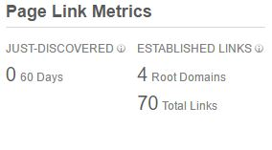

Your number of linking root domains is 70, it is too low when compared to many of the top sites whose topics overlap with the website.

Recommendations

We recommend working to significantly increase the number of linking root domains. There is still significant room for improvement.

There should be an emphasis on domain diversity (getting links from many different domains) and domain authority (a mix of high and medium quality sites). The creation of link worthy content, guest blog posts, and high profile press mentions should be a key focus.

Guidelines


The very best links come from trusted domains (sites like the New York Times, Wall Street Journal, Wired, Inc., TechCrunch, Huffington Post, Wikipedia, etc.). The more links you can get from authoritative websites, the better, and guest blog posts and press mentions are a great way to get those links.

LINKING ROOT DOMAINS
- SCORE
- 7/10

One of the things that Google looks at and factors into the algorithm is domain diversity. Essentially, the concept is that 10 links from 10 domains would be more valuable as a ranking factor than 10 links form one domain.

From an SEO perspective, you usually want to see a domain diversity of no less than 10% (i.e. 100 links from 10 domains), though higher is usually better. All other factors being equal, the site with the larger number of linking root domains would almost always rank higher. That said, in the case of extremely high quality sites an acceptable domain diversity could be as little as 2%.
AUTHORITY & TRUST

Analysis

Currently, the best metrics available to measure Authority and Trust are from SEOmoz, and are known as Domain Authority, mozRank and mozTrust. When we scanned the website, we found:
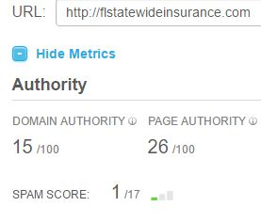

The Domain Authority is on a 100 point scale, with any site above 40 being considered a fairly good quality site, and sites above 70 being considered truly high quality. mozRank and mozTrust are very similar to Google’s PageRank, and serve to measure the distance of your site from trusted and authoritative websites.


These metrics place the website well above average in terms of trust and authority, and well on your way to becoming a highly trusted site. However, you're still lagging a bit behind other, similar sites.

Score
8/10

- SCORE
- 6/10

Recommendations

By further increasing the number of high-quality inbound links, and especially the number of high-quality linking root domains, the trust and authority will continue to increase. By focusing link building efforts on ever higher quality websites these metrics will increase faster than they would with links from average sites.

Guidelines

Pages earn mozRank based on the number and quality of other pages linking to them. The higher the quality of the incoming links, the higher the mozRank. mozTrust is determined by calculating link “distance” between a given page and a seeded trust source on the Internet, such as .edu and .gov pages.

SOCIAL MEDIA MENTIONS & VISIBILITY

Analysis

Here is what our analysis found:
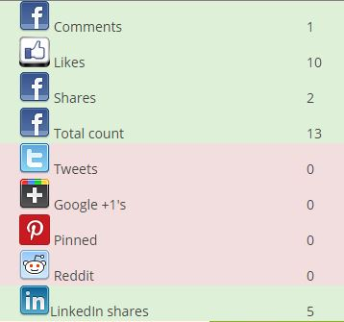

Recommendations

You should increase your social media presence as its going to affect your target audience and get you more customers.

Guidelines


When someone links to a website from their website, Google sees that as an endorsement, and that endorsement increases a website’s ability to rank well. Social signals have a similar effect.

Score
10/10

- SCORE
- 8/10

When someone tweets or shares a link to your website, that is seen as an endorsement much link a link. The “trust and authority” of the person who sent that link is treated just like trust and authority for a website, and is based on the authority of the social user. To make the most out of social, the key is to:
- Make it easy for people to share your content socially, by integrating sharing features throughout your website, blog posts, etc.
- And to create content that is worthy of sharing, and then reaching out to people in that space via social channels to ask for feedback about said content.

CONCLUSION
Overall, I found that the SEO situation on http://yoursite.com is average, particularly in regards to off-site SEO. That said, there is still room for improvement. By working to fix the issues identified in this audit, you’ll be able to achieve higher rankings for more keywords, and for more competitive keywords as well.

We’re confident that you will get there, and we’re here to help!

If you have any questions about your audit, feel free to contact me!

Khuram Malik

